電腦視覺 HW9

學生:葉政樑 學號:R08945006

1. 作業目標:

1. Roberts operator (threshold: 12)

2. Prewitt edge detector (threshold: 24)

3. Sobel edge detector (threshold: 38)

4. Frei and Chen gradient operator (threshold: 30)

5. Kirsch compass operator (threshold: 135)

6. Robinson compass operator (threshold: 43)

7. Nevatia-Babu 5×5 operator (threshold: 12500)

1. 作業流程:
2. 將Lena.bmp做Padding
3. 使用各個方式的kernal進行運算
4. 與threshold比較後輸出邊緣檢測結果影像

Kernal如下:

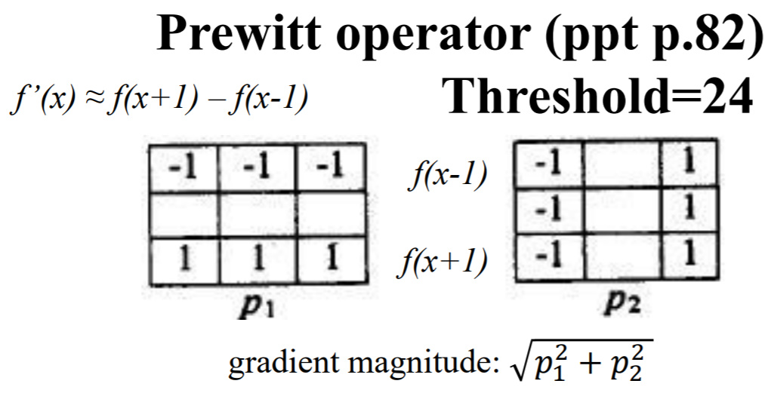

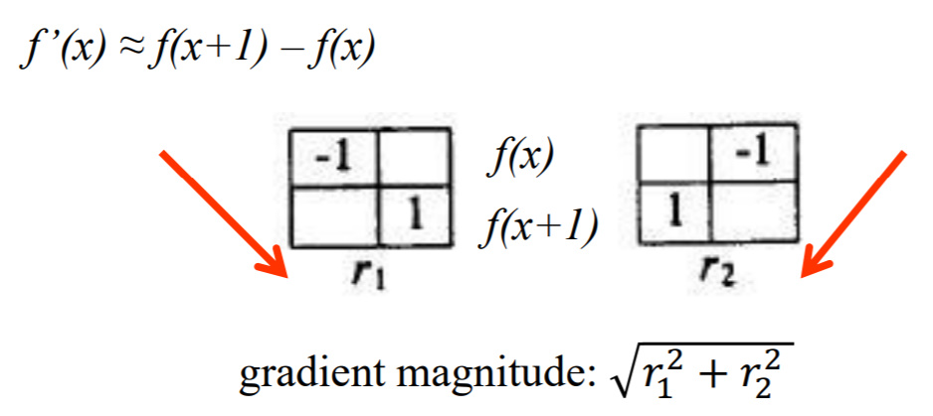

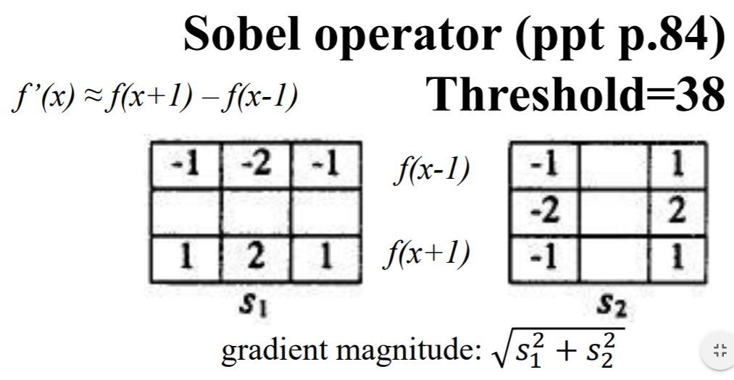

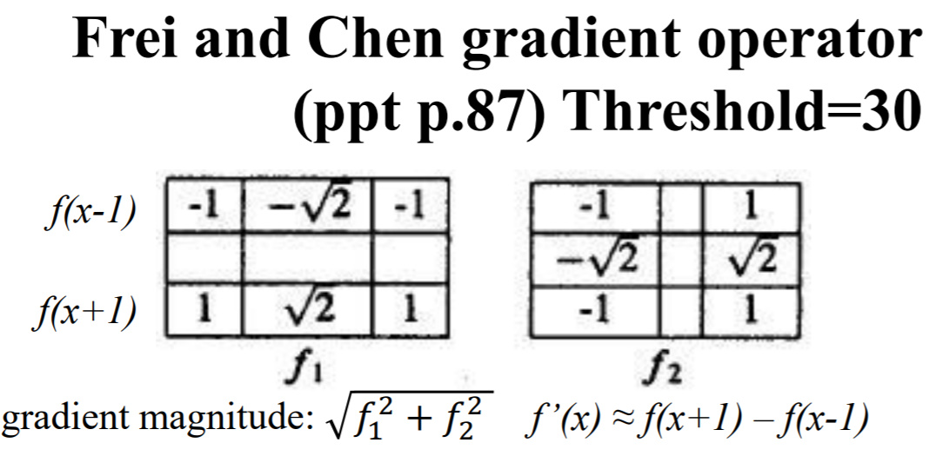

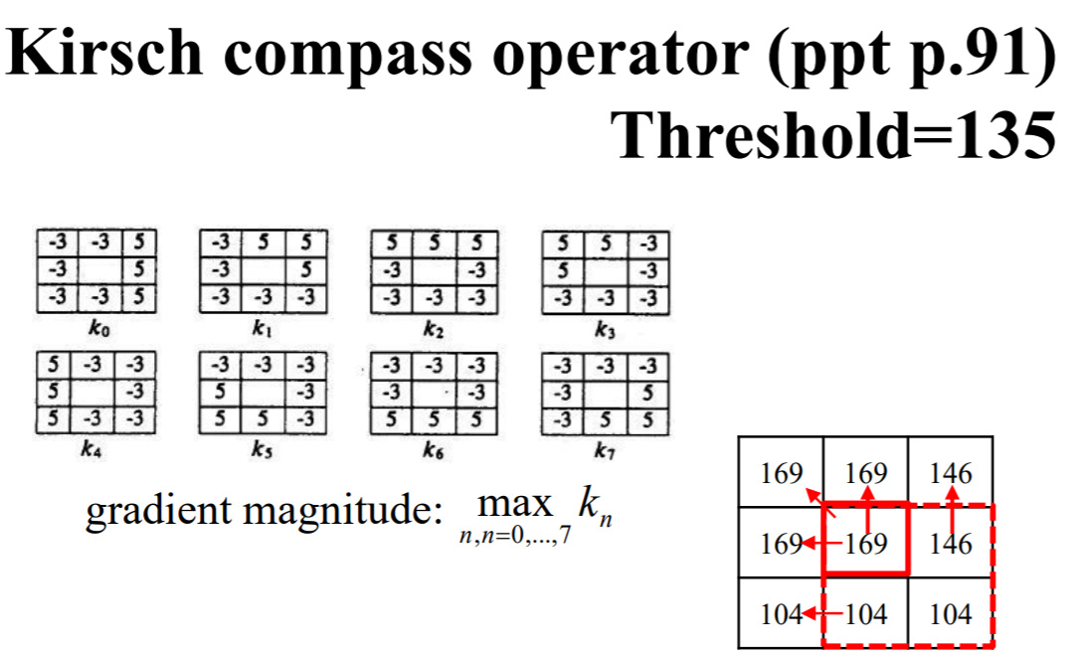

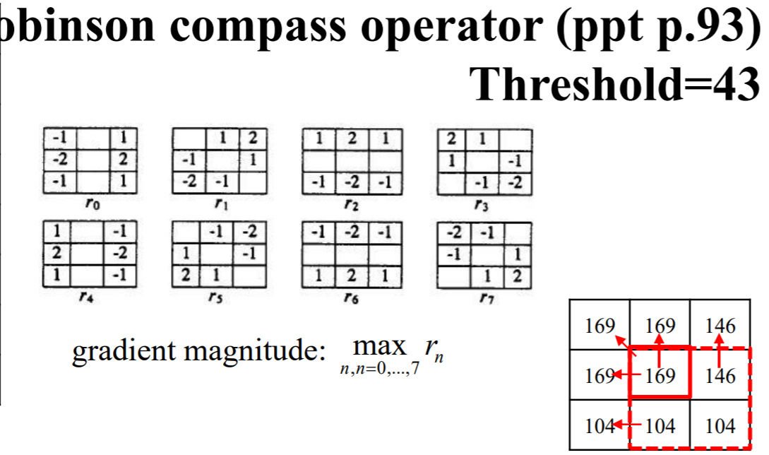

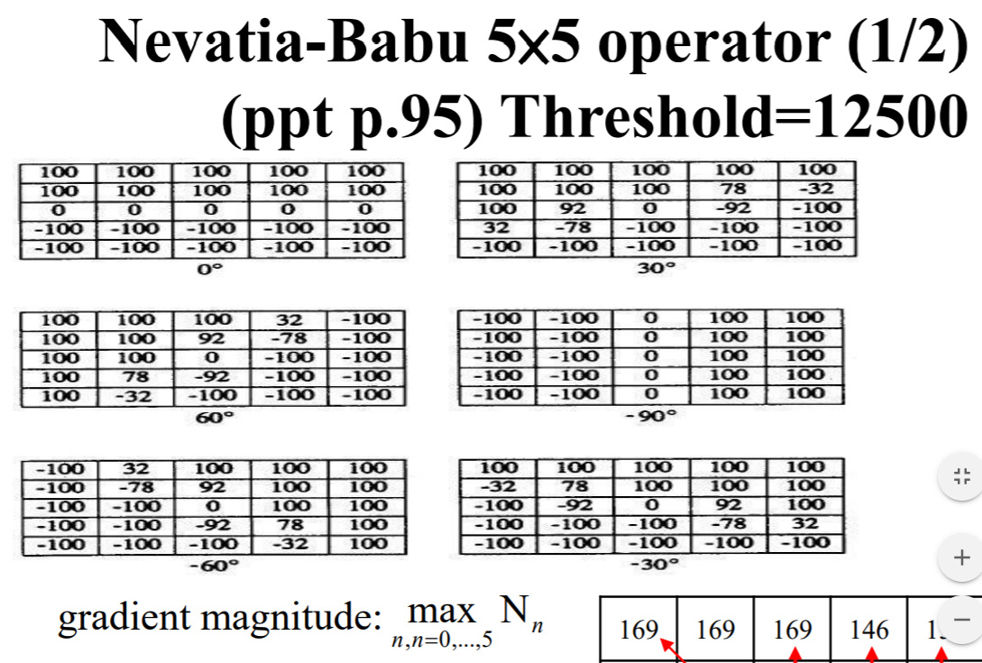

1. 結果:

|  |  |  |
| --- | --- | --- |
| Roberts operator  (threshold: 12) | Prewitt edge detector (threshold: 24) | Sobel edge detector (threshold: 38) |
| C:\Users\showt\AppData\Local\Microsoft\Windows\INetCache\Content.Word\Robert_t12_img.bmp |  |  |

|  |  |  |
| --- | --- | --- |
| Frei and Chen gradient operator (threshold: 30) | Kirsch compass operator (threshold: 135) | Robinson compass operator (threshold: 43) |
|  |  |  |

|  |
| --- |
| Nevatia-Babu 5×5 operator  (threshold: 12500) |
|  |

1. Code fragment(為排版沒依照順序):

